7 Working with Office documents

7.1 Creating an Office Document
Office documents are stored in Teamcenter in a dedicated item.
To create a new Office document please go to File → New → Item… and select the element “FFG Document”.
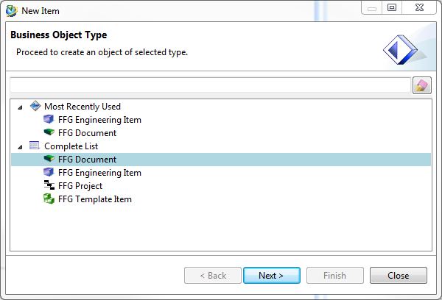
The following form will appear which must be filled in.
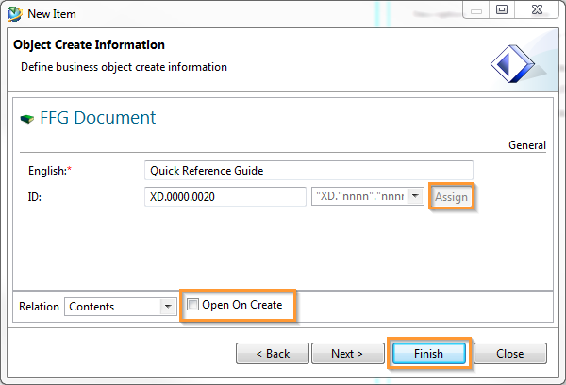
If you select “Open on creation” (recommended) before closing, the newly created item opens automatically. You can close the plant window.
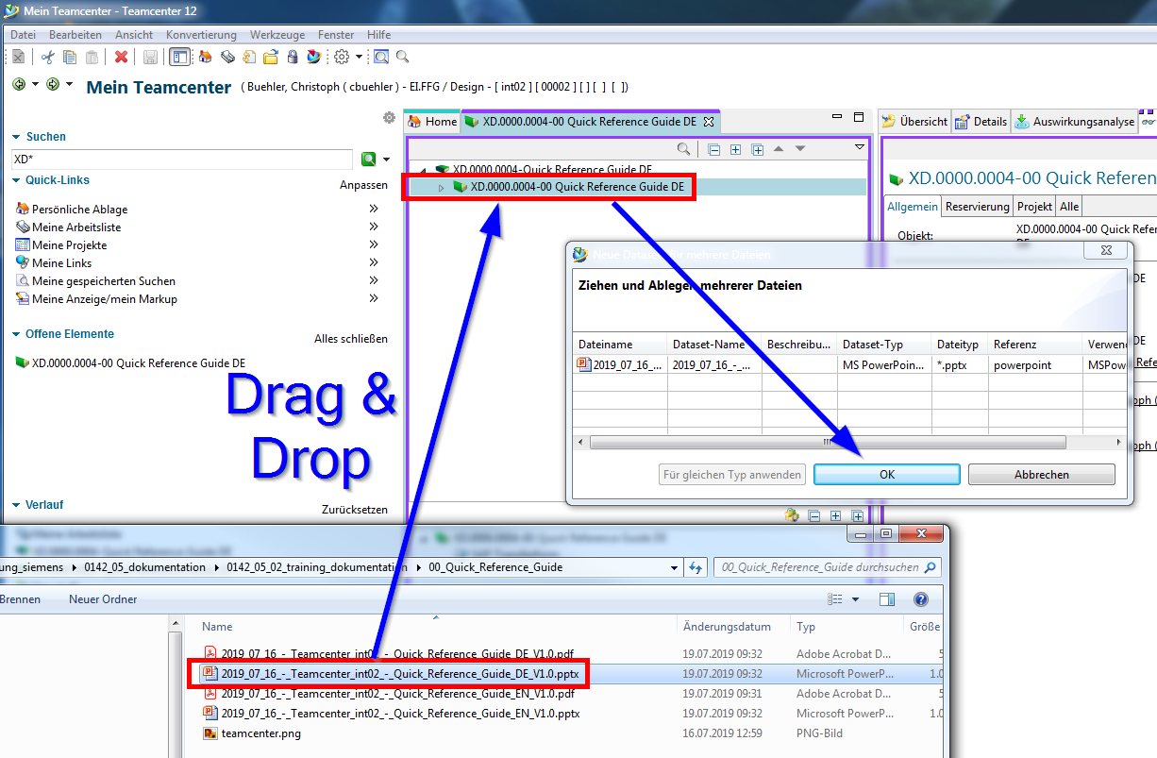
Now simply drag and drop the desired document onto the Revision item. Confirm with OK to check the document in to Teamcenter.
A double click on the document opens it automatically and unchecks it from Teamcenter.
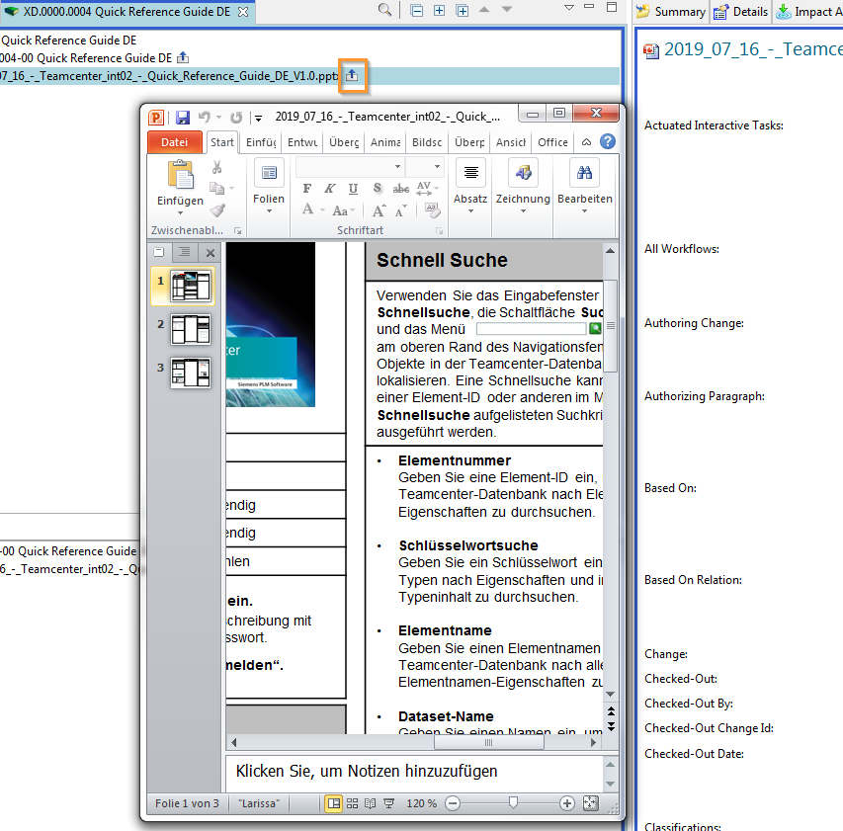
You can now make changes to the document. After saving and exiting the Office application, the document is automatically checked back into Teamcenter and your changes are saved.

