2nd function description

2.1. data model
The data model describes the objects in Teamcenter that are used by the integration to store project information.
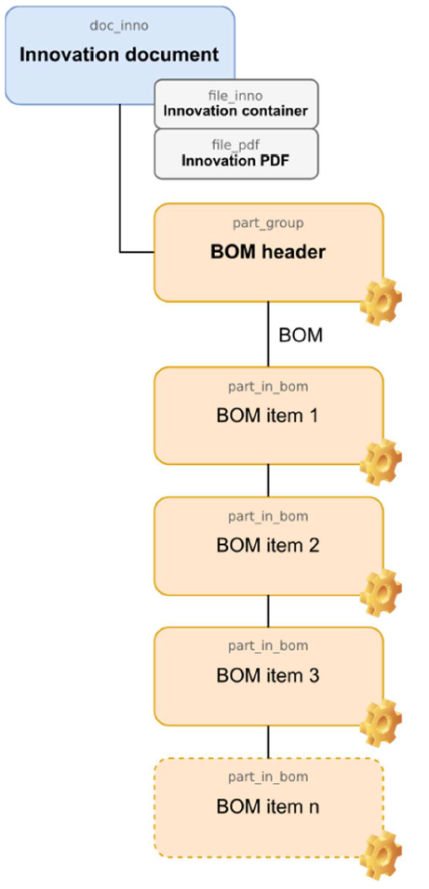
Legend:
- Blue boxes: Items
- Orange boxes: Items
- Grey boxes: Datasets

2.2. module dialogs
The integration functions are started as separate modules with their own dialogs from the Integrate menu in EPLAN.
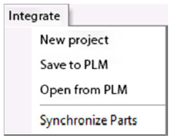
Menu: Integrates
- New Project: Creates a new project.
- Save to PLM: Manages all relevant project information in Teamcenter, for example the original project files, generated output files and the parts list(s).
- Open from PLM: Downloads the project files from Teamcenter and opens the project read-only or for editing in EPLAN.
- Synchronize Parts: Manages parts, items and attributes bidirectionally between the library and Teamcenter.
All module dialogs have the same structure and are divided into the following areas:
- Menu bar
- Main functions
- Event log

2.2.1 New Project
Use this integration module to create new projects based on templates or existing projects.
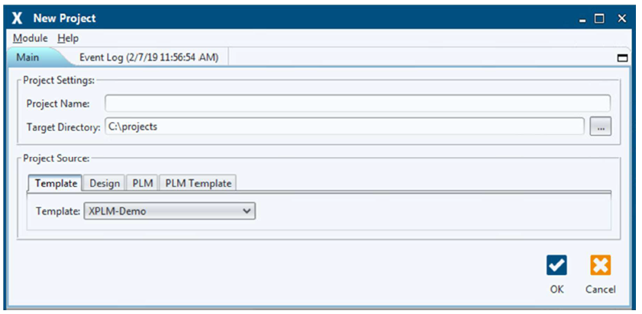
Area: Project Settings
In this area you can define the project name and the project directory.
Project Name: Defines the name of the project. Target Directory: Defines the directory where the project will be saved.
Project Source.
You can select a template or an existing project in this area.
Template: | Displays a selection list for templates stored in the template directory.
Design: | Opens a selection dialog for projects stored in the file system.
PLM: | Opens a search dialog for projects saved in Teamcenter.
PLM Template: | Displays a selection list for templates stored in Teamcenter.

