Basics
Most administrative tasks in Teamcenter require administration permissions, i.e. a user must have the group/role dba/DBA and must also switch to it to obtain administration permissions.
To change, click on your user name in the upper bar. Then select “Group” under “Group” and then select “dba”. The role “DBA” is automatically selected.
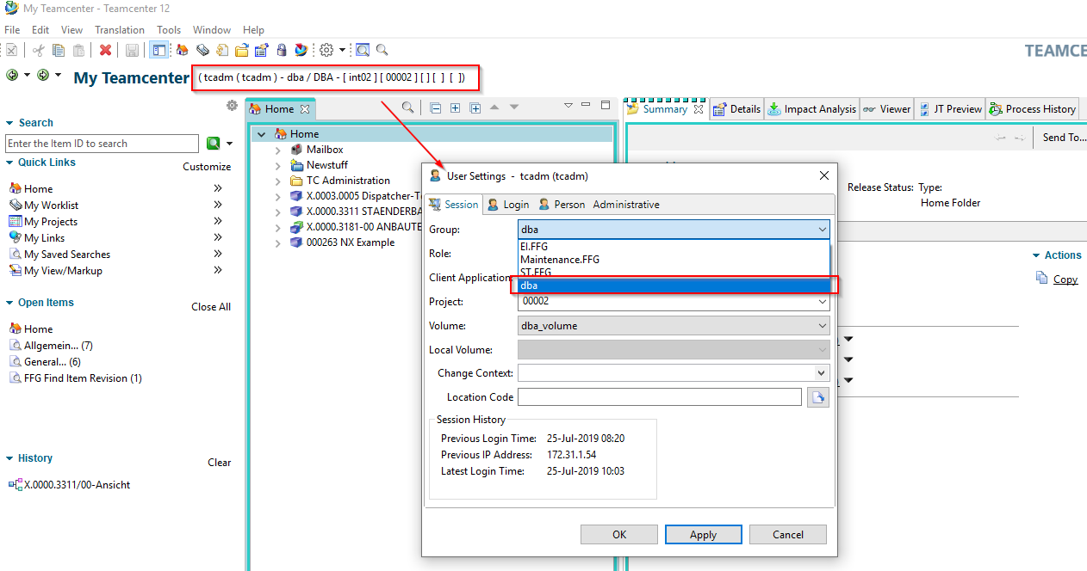
In the upper bar, “dba/DBA” is then displayed as a group/role combination.
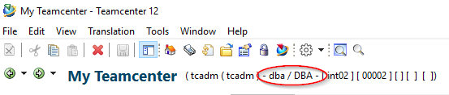
A funny video

